Cambridgeshire NHW
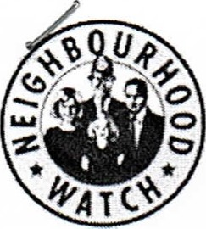
Version 3— Jan 2021
Page 1 of 1

No
1. | NHW Group Name
2. | Applicant's Contact details |  |  |  | phone
3. | Application is for:-
4. | No. of houses …… : Number of ALERT registered coordinators
5. | Does applying group have:- | Bank account? |  | Published Accounts
6. | Spending Proposal  Purpose:  The proposed purchase items are listed in the associated spreadsheet.
 | Amount requested: (note that the maximum amount is normally 2200)
 | Has your scheme received funding from any other source over the last twelve months?
9. | Please list other organisations approached for funding and note any sums received.
Signature |  |  | Role held in NHW group applying:
Date of application
The completed form should, preferably, be emailed to the Cambridgeshire NHW Treasurer at John Fuller -john.full80@ntlworld.com. If sending a paper based application, please contact the Treasurer or your area coordinator for the address.

