CAMBRIDGESHIRE NEIGHBOURHOOD WATCH CONSTITUTION
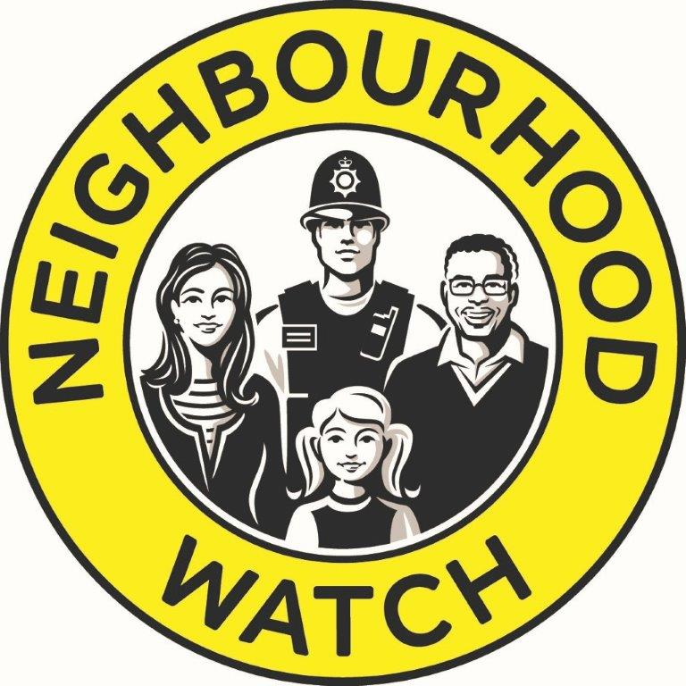

Date of Adoption: 22nd September 2018
Version: 1.0

1. Name of the Organisation
1.1 The name of the organisation is Cambridgeshire Neighbourhood Watch (hereinafter referred to as ‘CNHW’ or ‘the Association’.

1.2 The Association shall be a not for profit organisation, non-party in politics, non-sectarian in religion, operate an equal opportunities and non-discriminatory policy and will embrace diversity.

1.3 There are two constituted district associations namely Peterborough Neighbourhood Watch Association and East Cambridgeshire Neighbourhood Watch Association existing within the CNHW association.

2. Objectives of the Organisation
2.1 The objectives of the organisation are:

- Provide local leadership, strategic direction, advice, governance and guidance to Neighbourhood Watch members, community partners and the public in Cambridgeshire.

- Assist with the creation, development and support of Neighbourhood Watch Associations and Groups located across Cambridgeshire.

- Promote good citizenship and greater public awareness, increase public participation in the prevention and detection of crime, and reduce the fear of crime.

- Improve police/community liaison and increase community safety in partnership with recognised Authorities and other relevant organisations.

3. Powers
In furtherance of the said Objectives the Association may:
3.1 Promote and assist in the development of Neighbourhood Watch Associations and Groups across Cambridgeshire and participate in the wider promotion of Neighbourhood Watch more generally.
3.2 Carry out research and surveys, provide and communicate information, services and advice to and on behalf of all Association Members, exchange information and share and promote best effective practice and acceptable behaviour and performance standards amongst all Neighbourhood Watch entities, and where relevant with other organisations. Provide relevant, accurate and timely information to the public and media in appropriate circumstances.
3.3 Act as a forum, coordinate resources and provide services for Association Members as appropriate, including the provision of small grants to Association Members when considered appropriate, arranging, providing for or assisting in the holding of meetings, seminars, training courses, exhibitions and the like.
3.4 Act as a consultative and advisory body to Authorities on matters affecting Neighbourhood Watch in Cambridgeshire. Represent the views and needs of Association Members and exchange information where appropriate to/with Authorities and other Neighbourhood Watch entities.
3.5 Raise funds, secure sponsorship, invite and receive donations from any persons or bodies by way of subscription or otherwise, accept gifts and borrow or raise money in such a prudent, reasonable and legal manner as the Association Executive Committee shall think fit.

4. Membership
4.1 Membership of CNHW shall be open to all members of Neighbourhood Watch Schemes that are approved by CNHW and Cambridgeshire Constabulary in the county of Cambridgeshire.
4.2 Members who volunteer and become ‘approved’ scheme coordinators will be known as ‘Authorised Members’.
4.3 Additional representation nominated by Cambridgeshire Police and Cambridgeshire’s Police and Crime Commissioner shall be entitled to attend and speak at meetings but will not be deemed an Association member or permitted to vote on any issue.
4.4 The Association must keep a register of names and contact details of Authorised Members.

5. Management of CNHW
5.1. CNHW will be managed by an Executive Committee, elected annually by Authorised Members at the Association’s Annual General Meeting, who shall be responsible for the general control and management of the Association.
5.2 The Executive Committee will be made up of CNHW Authorised Members and comprise: Chair, Secretary and Treasurer who will be the officers of the Association.
Additionally, not more than 12 other members will form the committee.
Subject to para. 5.3 below, where possible, there will be at least one representative from each of the 5 districts and one unitary authority that make up Cambridgeshire.

5.3 Where a constituted District Association exists they will nominate an officer representative to sit on the Executive Committee.
5.4 The Executive Committee will elect its Officers from the committee elected by Authorised Members and those appointed by District Associations.
5.5 The Executive Committee shall have the power to co-opt up to 3 additional Neighbourhood Watch members residing in Cambridgeshire, to fill vacant positions or assist the Executive Officers should the need arise, in order to maintain the integrity and effectiveness of the Association.
5.6 The Executive Committee will appoint from their committee a CNHW Communications Administrator who will be responsible for the register of Schemes/Coordinators and provide support to district administrators.
A co-opted member may be appointed to this role if the committee is unable to appoint from within. A deputy administrator may also be appointed.
5.7 The Executive Committee will meet not less than 3 times a year. There must be at least 5 voting members at an Executive Committee meeting including an Officer. Minutes will be produced and approved at the next meeting and then posted on the organisation’s website.
5.8 All Executive and co-opted members shall retire at each Annual General Meeting following their appointment but shall be eligible for re-election.

6. Termination of Membership
6.1 An Authorised Member may resign by giving written notice to their Association representative or the CNHW Communication Administrator.
An Executive Committee member may resign by giving written notice to the Association Secretary/Chairman which will take effect on the date the member requests.
Officers of the association who wish to resign will notify the Secretary/Chairman in writing and, other than in exceptional circumstances, will take effect from the date of the next Annual General Meeting.
6.2 The Executive Committee shall have the right to decline, discipline, suspend or terminate the membership of any Neighbourhood Watch member in Cambridgeshire, including a member of any Committee or sub-Committee, who displays unacceptable behaviour or performance standards, commits any illegal act, or conducts themselves in a manner which threatens or may threaten to bring into disrepute the good name or reputation of Neighbourhood Watch or its members, or causes or may cause Neighbourhood Watch co-ordinators or members to resign.
Such a member and if applicable, their representative, shall be afforded the opportunity of being heard by a panel of not less than 3 Executive Members, one of whom shall be an officer.
6.3 The agreement by a simple majority of the panel shall be necessary to decline, discipline, suspend or terminate any membership.
6.4. In the event that the disciplined member finds the outcome unreasonable they may appeal to the Chairman who will convene an Appeals Panel and whose decision will be final.

7. General Meetings
7.1 The Annual General Meeting of the Association shall be held in September each year or as soon as practicable within 4 weeks thereafter.
At least 28 clear days’ notice in writing shall be given by the Secretary to each Executive and Authorised Member. Notice given electronically shall be deemed to be notice in writing.

7.2 The Executive Committee may at their discretion declare the Annual General Meeting or any Extraordinary General Meeting to be open to all CNHW members residing in Cambridgeshire.
7.3 The quorum at a general meeting will be 25 Authorised Members including at least one Officer.
7.4 At the Annual General Meeting, Authorised Members or in their absence, their named and notified nominee, shall elect the members of the Executive Committee.
7.5 Nominations for the Executive Officers, duly proposed and seconded, shall be delivered to the Secretary at least 14 days before the Annual General Meeting, with the consent of each nominee.
Retiring Executive Officers standing for re-election shall not be required to deliver such notice. In the event of no nominations being received for a post prior to the Meeting, at the discretion of the Chair nominations may be accepted from the floor.
7.6 An Extraordinary General Meeting may be convened at the discretion of the Executive Committee or by a written request made to the Secretary by at least 100 Authorised Members of the Association stating the specific reasons.
The Secretary shall within a reasonable time convene a meeting subject to 21 clear days’ notice given to all Authorised Members. Every such person shall be entitled to attend and vote at the Extraordinary General Meeting.

8. Conduct at Meetings
8.1 At Executive Committee meetings 5 of the Committee Membership in attendance shall constitute a quorum.
8.2 Resolutions shall be proposed and seconded, and ordinarily be passed by a majority of votes on a show of hands.
However, a secret ballot may be held upon request of any Executive Officer. This shall be adjudicated by an independent person and the outcome recorded in the Minutes of that meeting.
8.3 The Chair of a meeting, when entitled to a vote, shall in the event of a tie also have a second or casting vote at that meeting.
8.4 Minutes, including drafts, will be produced and kept by the Secretary and posted on the CNHW website within one month of the meeting.

9. Finance
9.1 The financial year shall end on 30th June.
9.2 All monies raised by or on behalf of the Association shall be applied to further the purposes of the Association and not otherwise.
Nothing herein contained shall prevent the reimbursement in good faith of reasonable out-of-pocket expenses necessarily and properly incurred in furtherance of the Objectives.
9.3 The Treasurer shall keep proper and accurate Accounts of the finances of the Association.
The Treasurer will report to each meeting of the Association, at each Annual General Meeting, and whenever requested by the Executive Committee, a true and fair view of the financial situation of the Association.
9.4 A bank account shall be maintained in the name of the Association with such bank as the Executive Committee shall from time to time decide. The Executive Committee shall authorise in writing nominated Executive members, one always being the Treasurer, who shall from time to time determine to make payments or sign cheques on behalf of the Association. All payment authorisations and cheques must be signed by two of the authorised signatories.
9.5 The Annual Financial Report and audited accounts shall be submitted by the Executive Committee to the AGM.

10. Dissolution
10.1 If the Executive Committee decide, by a simple majority, it is necessary or advisable to dissolve the Association, the Chairman shall call an Extraordinary General Meeting stating the terms of the Resolution to be proposed thereat.
If such decisions shall be confirmed by a 75% majority of votes of those present and voting at such meeting, the Executive Committee shall have the power to dispose of any assets held by or on behalf of the Association.
10.2 Any assets remaining after the satisfaction of any proper debts and liabilities shall be given or transferred to such other charitable institution or institutions having objects similar to the objects of the Association as the Executive Committee may decide or may be applied for some other charitable or Neighbourhood Watch purpose.

11. Amendments to the Constitution
11.1 Any proposed alterations to this Constitution shall require the assent of not less than 75% majority of votes of those present and voting at an Annual General Meeting.
Notice of any such alteration must have been received by the Secretary in writing not less than 21 clear days before the Meeting at which the alterations are to be proposed.
At least 14 clear days’ notice in writing of such a Meeting, setting out the terms of the proposed alterations, must be sent by the Secretary to every Authorised Member.

11.2 In circumstances where minor changes to the Constitution are deemed necessary, such changes may be made following a simple majority vote of approval by the Executive Committee. These changes, including such items as change of name, change of Committee numbers and/or responsibilities, frequency of meetings, etc., that are considered necessary by circumstances prevailing at the time, may be made provided that such changes in no way alter Clauses 2, 10 or 11.

12. Declaration of Adoption
12.1 On behalf of the Cambridgeshire Neighbourhood Watch Association, I hereby declare that this This Constitution was approved and adopted at the 2018 Annual General Meeting on 22nd September 2018

Signature:  John Fuller  Role: Force Association Chairman | Signature:  Morcom Lunt  Role: Force Association Treasurer

